Bibiana Obler

Arp, Hans/Jean (1886–1966)

Hans/Jean Arp, an Alsatian poet and artist, was a founding member of Dada and an active participant in Constructivism and Surrealism. Arp grew up in Strasbourg speaking German, French, and Alsatian. He studied fine arts in Strasbourg, Weimar, and Paris, and even early in his career was active in international artistic and literary circles. In 1910, he co-founded the Moderne Bund and contributed to the Blue Rider Almanac. A German citizen, Arp successfully dodged the draft during World War I, finding refuge first in Paris and then in Zurich. At an exhibition that featured his embroideries, tapestries, and works on paper at the Tanner Gallery, he met Sophie Taeuber, who soon became a friend and collaborator and, in October 1922, his wife. Early in their friendship her exploration of strict geometries led to a series of collaborative vertical-horizontal compositions in collage and embroidery that are among the earliest purely abstract works produced by European avant-gardes. In 1916, Arp joined Hugo Ball, Tristan Tzara, and others in launching Dada. Informed by mysticism and Eastern philosophies, Arp sought to transcend the boundedness of individual production by working with chance, thus deliberately relinquishing some control over the process of making. Inspired by the natural environs of Lake Maggiore, Ascona, he explored biomorphic forms in ink, wood, and embroidery. Arp developed this organic vocabulary throughout his career. Beginning in the 1930s, he focused increasingly on sculpture in durable materials such as marble and bronze.

Arp, an active member of Dada in Zurich, Berlin, Cologne, and Paris, participated in performances, designed costumes and sets, exhibited artwork including collages and wood reliefs, and contributed woodcuts and poetry to Dadaist journals. He traveled extensively in the early 1920s before settling in Clamart, near Paris, around 1928. He had become a French citizen in 1926, thanks to his Alsatian origins. He developed an “object language,” a personally and spiritually charged iconography of elements such as the navel, moustache, egg, and necktie, which he deployed in unexpected juxtapositions in his visual and written art. Moving fluidly between abstraction and figuration, he avoided becoming embroiled in the fractious politics of the 1920s art world and frequented Surrealist meetings while remaining a Dadaist and champion of concrete art (Cercle et Carré, Abstraction-Création). Dedicated to collaboration throughout his career, Arp worked closely on artistic projects with a wide variety of colleagues — including Theo van Doesburg, Marcel Duchamp, Max Ernst, Vicente Hidobro, Kurt Schwitters, and Taeuber — in the 1920s and 1930s. In 1930, Arp turned increasingly to sculpture in the round, such as his organic but otherworldly Human Concretions, made of durable materials such as wood, stone, bronze, clay, and plaster.

At age 50, in response to National Socialism, Arp stopped writing his poetry in German and started writing in French. Only in 1939 did he start going by Jean rather than Hans. He escaped Paris with Taeuber before the Germans arrived in 1939, seeking refuge first in the south of France, then returning to Switzerland in 1942, where Taeuber died in January 1943. Devastated, Arp stopped making sculpture for five years and dedicated many reliefs and poems to Taeuber's memory. In the late 1940s, Arp resumed his busy production and exhibition schedule, remaining artistically active until his death in 1966.

References and further reading

Arp, Hans. Jours éffeuillés. Poèmes, essais, souvenirs 1920-1965. Paris: Gallimard, 1966.

-------------. Unsern Täglichen Traum... Erinnerungen und Dichtungen aus den Jahren 1914–1954. Zurich: Arche, 1955.

Arp, Jean. Arp on Arp: Poems, Essays, Memories. Joachim Neugroschel, trans. New York: Viking, 1972.

------------. On My Way: Poetry and Essays 1912-1947. New York: Wittenborn, Schultz, 1948.

Arp, Hans and El Lissitzky, eds. Die Kunstismen/Les isme de l'art/ The Isms of Art. Erlenbach-Zürich: Eugen Rentsch, 1925.

Hancock, Jane and Stefanie Poley. Arp. Cambridge: Cambridge University Press, 1987.

Obler, Bibiana. Intimate Collaborations: Kandinsky and Münter, Arp and Taeuber. New Haven: Yale University Press, 2014.

Rau, Bernd. Jean Arp: The Reliefs: Catalogue of Complete Works. New York: Rizzoli, 1981.

Read, Herbert. The Art of Jean Arp. New York: Abrams, 1968.

Robertson, Eric. Arp: Painter, Poet, Sculptor. New Haven: Yale University Press, 2006.

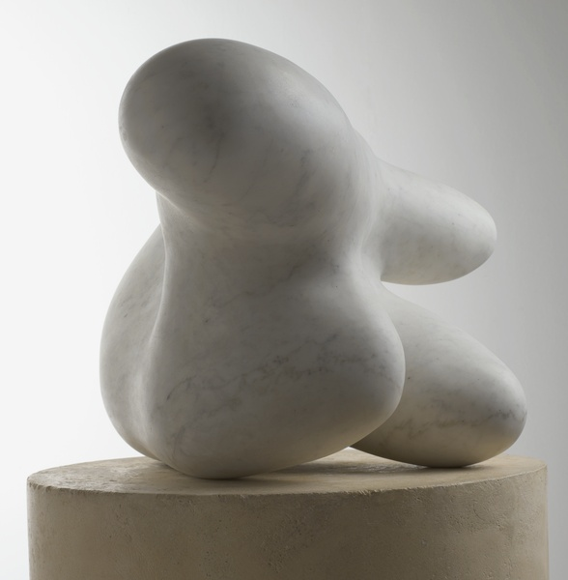

Image: Arp, Concrétion humaine (torse-fruit), 1934, white marble. 32 x 56 x 43 cm. Musée national d’art moderne, Centre Georges Pompidou, Paris. Inv. AM 896 S

http://www.photo.rmn.fr/cf/htm/CPicZ.aspx?E=2C6NU0C6KHQS

